**Diploma in Information Technology**

**Data Management & Security**

**CA3 Group Assignment**

**Apr 2023 Semester**

|  |  |  |
| --- | --- | --- |
| **No.** | **Name** | **SIM Student No.** |
| L1. | Angeles Micah Josephine Flores | 10240945 |
| M2. | Sumcad Bryce Nicolas Fernandez | 10244185 |
| M3. | Ho Ka Yan Jeslyn | 10241485 |
| M4. | Eng Wei Quan Bill | 10243810 |
| M5. | Liam Israel | 10241506 |

**Date of Submission: 15 May 2023Table of Content**

1 Contribution 3

2 Part 1: User Data Setup 4

2.1 ER Diagram 4

2.2 Create Table 5

2.2.1 SFVI.USER 5

2.2.2 SFVI.CD_TOPIC_CATEGORY 5

2.2.3 SFVI.TOPIC 5

2.2.4 SFVI.USER_TOPIC 6

2.3 Loading Tables From CSV 6

2.3.1 SFVI.USER 7

2.3.2 SFVI.CD_TOPIC_CATEGORY 7

2.3.3 SFVI.TOPIC 8

2.3.4 SFVI.USER_TOPIC 9

2.4 Load Tables Using Insert Statements 10

2.4.1 SFVI.USER 10

2.4.2 SFVI.CD_TOPIC_CATEGORY 10

2.4.3 SFVI.TOPIC 10

2.4.4 SFVI.USER_TOPIC 11

3 Part 2: Migrating Old Post Messages 12

3.1 ER Diagram 12

3.2 Create Table 12

3.2.1 SFVI.FORUM 12

3.2.2 SFVI.LOGIN_LOGOUT_DETAILS 13

3.3 Loading Tables From CSV 14

3.3.1 SFVI.FORUM 14

3.3.2 SFVI.LOGIN_LOGOUT_DETAILS 15

3.4 Load Tables Using Insert Statements 16

3.4.1 SFVI.FORUM 16

3.4.2 SFVI.LOGIN_LOGOUT_DETAILS 19

3.5 Usage Report 22

3.5.1 Number of Topics and Posts 22

3.5.2 Time Spent On The Game 23

4 Part 3: New Features 24

4.1 ER Diagram 24

4.2 Create Table 24

4.2.1 SFVI.USER_SUBSCRIPTION 24

4.3 Loading Tables From CSV 25

4.3.1 SFVI.USER_SUBSCRIPTION 25

4.4 Load Tables Using Insert Statements 26

4.4.1 SFVI.USER_SUBSCRIPTION 26

4.5 SQL Query 28

4.5.1 Number of Posts Between October 2022 to December 2022 28

4.5.2 Number of Post by Quarter 29

5 Summary 30

6 Annex A: SFVI Forum Message Data.csv 33

7 Annex B: SFVI Forum Users.csv 33

8 Annex C: CSV Files for Loading 33

# Contribution

|  |  |
| --- | --- |
| **Contribution** | **Members** |
| Design database schema | All |
| Create table scripts | | Jeslyn  Liam  Bill |
| Insert data scripts | Micah  Bryce |
| Documentation + ERD + User report scripts | Part 1 – Micah, Liam, Bill  Part 2 – Bill, Liam, Jeslyn  Part 3 – Jeslyn, Micah, Bryce |
| Summary | Jeslyn, Bryce, Micah |

# Part 1: User Data Setup

## ER Diagram

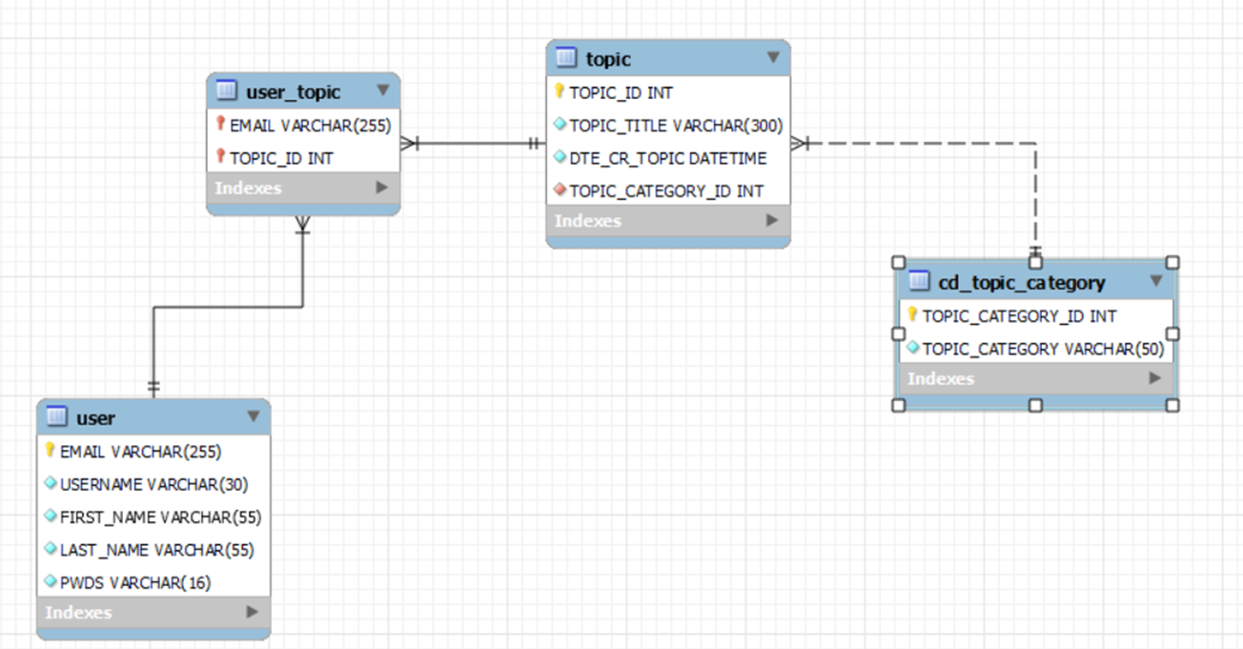

## Create Table

Below are the SQL scripts for table creation.

### SFVI.USER

CREATE TABLE SFVI.USER (

EMAIL VARCHAR(255) PRIMARY KEY,

USERNAME VARCHAR(30) NOT NULL,

FIRST_NAME VARCHAR(55) NOT NULL,

LAST_NAME VARCHAR(55) NOT NULL,

PWDS VARCHAR(16) NOT NULL

);

### SFVI.CD_TOPIC_CATEGORY

CREATE TABLE SFVI.CD_TOPIC_CATEGORY (

TOPIC_CATEGORY_ID INT AUTO_INCREMENT PRIMARY KEY,

TOPIC_CATEGORY VARCHAR(50) NOT NULL

);

### SFVI.TOPIC

CREATE TABLE SFVI.TOPIC (

TOPIC_ID INT AUTO_INCREMENT PRIMARY KEY,

TOPIC_TITLE VARCHAR(300) NOT NULL,

DTE_CR_TOPIC DATETIME NOT NULL DEFAULT CURRENT_TIMESTAMP,

TOPIC_CATEGORY_ID INT(9) NOT NULL,

FOREIGN KEY (TOPIC_CATEGORY_ID) REFERENCES SFVI.CD_TOPIC_CATEGORY(TOPIC_CATEGORY_ID)

);

### SFVI.USER_TOPIC

CREATE TABLE SFVI.USER_TOPIC (

EMAIL VARCHAR(255),

TOPIC_ID INT,

PRIMARY KEY (EMAIL, TOPIC_ID),

FOREIGN KEY (EMAIL) REFERENCES SFVI.USER(EMAIL),

FOREIGN KEY (TOPIC_ID) REFERENCES SFVI.TOPIC(TOPIC_ID)

);

## Loading Tables From CSV

SQL scripts to load the data from csv files to tables. Please note that MySQL Workbench 8.0 CE is running with --secure-file-priv option. By executing the command SHOW VARIABLES LIKE "secure_file_priv"; it tells us that we need to put the csv files in C:\ProgramData\MySQL\MySQL Server 8.0\Uploads.

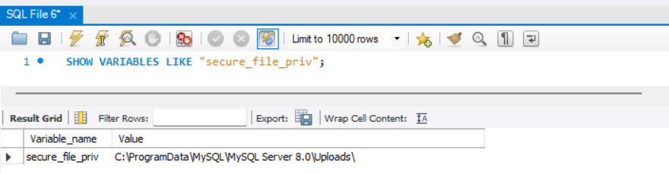

### SFVI.USER

LOAD DATA INFILE 'C:/ProgramData/MySQL/MySQL Server 8.0/Uploads/USER.csv'

INTO TABLE SFVI.USER

FIELDS TERMINATED BY ','

ENCLOSED BY '"'

LINES TERMINATED BY '\n'

IGNORE 1 ROWS

(EMAIL, USERNAME, FIRST_NAME, LAST_NAME, PWDS);

**Output:**

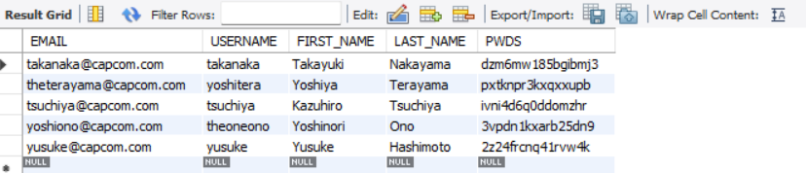

### SFVI.CD_TOPIC_CATEGORY

LOAD DATA INFILE 'C:/ProgramData/MySQL/MySQL Server 8.0/Uploads/CD_TOPIC_CATEGORY.csv'

INTO TABLE SFVI.CD_TOPIC_CATEGORY

FIELDS TERMINATED BY ','

ENCLOSED BY '"'

LINES TERMINATED BY '\n'

IGNORE 1 ROWS

(TOPIC_CATEGORY_ID, TOPIC_CATEGORY);

**Output:**

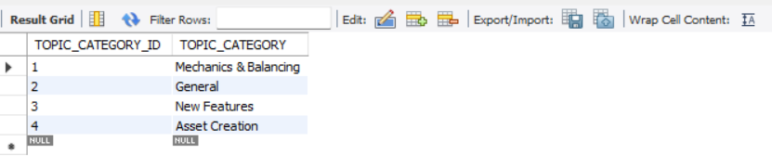

### SFVI.TOPIC

LOAD DATA INFILE 'C:/ProgramData/MySQL/MySQL Server 8.0/Uploads/TOPIC.csv'

INTO TABLE SFVI.TOPIC

FIELDS TERMINATED BY ','

ENCLOSED BY '"'

LINES TERMINATED BY '\n'

IGNORE 1 ROWS

(TOPIC_ID, TOPIC_TITLE, @DTE_CR_TOPIC, TOPIC_CATEGORY_ID)

SET DTE_CR_TOPIC = STR_TO_DATE( @DTE_CR_TOPIC, '%d/%m/%Y %H:%i:%s');

**Output:**

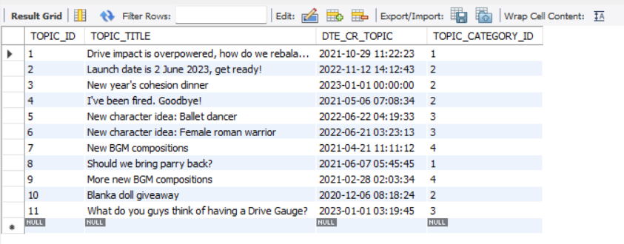

### SFVI.USER_TOPIC

LOAD DATA INFILE 'C:/ProgramData/MySQL/MySQL Server 8.0/Uploads/USER_TOPIC.csv'

INTO TABLE SFVI.USER_TOPIC

FIELDS TERMINATED BY ','

ENCLOSED BY '"'

LINES TERMINATED BY '\n'

IGNORE 1 ROWS

(EMAIL, TOPIC_ID);

**Output:**

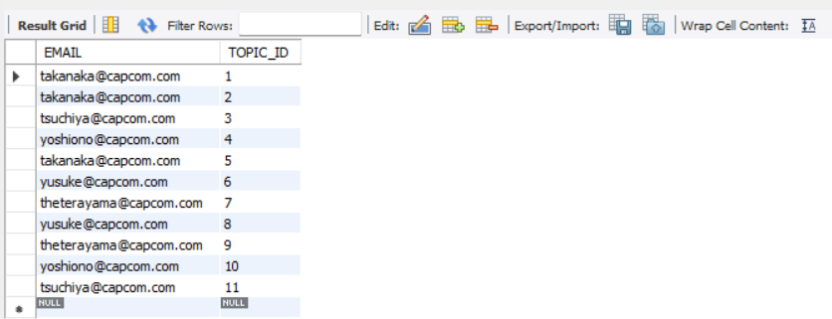

## Load Tables Using Insert Statements

Below are the SQL scripts to load the table using insert statements as an alternative of loading the tables from CSV files.

### SFVI.USER

INSERT sfvi.user (email, username, first_name, last_name, pwds) VALUES ('takanaka@capcom.com','takanaka','Takayuki','Nakayama','dzm6mw185bgibmj3');

INSERT sfvi.user (email, username, first_name, last_name, pwds) VALUES ('tsuchiya@capcom.com','tsuchiya','Kazuhiro','Tsuchiya','ivni4d6q0ddomzhr');

INSERT sfvi.user (email, username, first_name, last_name, pwds) VALUES ('yoshiono@capcom.com','theoneono','Yoshinori','Ono','3vpdn1kxarb25dn9');

INSERT sfvi.user (email, username, first_name, last_name, pwds) VALUES ('yusuke@capcom.com','yusuke','Yusuke','Hashimoto','2z24frcnq41rvw4k');

INSERT sfvi.user (email, username, first_name, last_name, pwds) VALUES ('theterayama@capcom.com','yoshitera','Yoshiya','Terayama','pxtknpr3kxqxxupb');

### SFVI.CD_TOPIC_CATEGORY

INSERT sfvi.cd_topic_category (topic_category) values ('Mechanics & Balancing');

INSERT sfvi.cd_topic_category (topic_category) VALUES ('General');

INSERT sfvi.cd_topic_category (topic_category) VALUES ('New Features');

INSERT sfvi.cd_topic_category (topic_category) VALUES ('Asset Creation');

### SFVI.TOPIC

INSERT sfvi.topic (topic_title, dte_cr_topic, topic_category_id) values ('Drive impact is overpowered, how do we rebalance it?', STR_TO_DATE("29/10/2021 11:22:23", "%d/%m/%Y %H:%i:%s"), 1);

INSERT sfvi.topic (topic_title, dte_cr_topic, topic_category_id) values ('Launch date is 2 June 2023, get ready!', STR_TO_DATE("12/11/2022 14:12:43", "%d/%m/%Y %H:%i:%s"), 2);

INSERT sfvi.topic (topic_title, dte_cr_topic, topic_category_id) values ('New year''s cohesion dinner', STR_TO_DATE("01/01/2023 00:00:00", "%d/%m/%Y %H:%i:%s"), 2);

INSERT sfvi.topic (topic_title, dte_cr_topic, topic_category_id) values ('I''ve been fired. Goodbye!', STR_TO_DATE("06/05/2021 07:08:34", "%d/%m/%Y %H:%i:%s"), 2);

INSERT sfvi.topic (topic_title, dte_cr_topic, topic_category_id) values ('New character idea: Ballet dancer', STR_TO_DATE("22/06/2022 04:19:33", "%d/%m/%Y %H:%i:%s"), 3);

INSERT sfvi.topic (topic_title, dte_cr_topic, topic_category_id) values ('New character idea: Female roman warrior', STR_TO_DATE("21/06/2022 03:23:13", "%d/%m/%Y %H:%i:%s"), 3);

INSERT sfvi.topic (topic_title, dte_cr_topic, topic_category_id) values ('New BGM compositions', STR_TO_DATE("21/04/2021 11:11:12", "%d/%m/%Y %H:%i:%s"), 4);

INSERT sfvi.topic (topic_title, dte_cr_topic, topic_category_id) values ('Should we bring parry back?', STR_TO_DATE("07/06/2021 05:45:45", "%d/%m/%Y %H:%i:%s"), 1);

INSERT sfvi.topic (topic_title, dte_cr_topic, topic_category_id) values ('More new BGM compositions', STR_TO_DATE("28/02/2021 02:03:34", "%d/%m/%Y %H:%i:%s"), 4);

INSERT sfvi.topic (topic_title, dte_cr_topic, topic_category_id) values ('Blanka doll giveaway', STR_TO_DATE("06/12/2020 08:18:24", "%d/%m/%Y %H:%i:%s"), 2);

INSERT sfvi.topic (topic_title, dte_cr_topic, topic_category_id) values ('What do you guys think of having a Drive Gauge?', STR_TO_DATE("01/01/2023 03:19:45", "%d/%m/%Y %H:%i:%s"), 3);

### SFVI.USER_TOPIC

INSERT sfvi.USER_TOPIC (EMAIL, TOPIC_ID) values ('takanaka@capcom.com', 1);

INSERT sfvi.USER_TOPIC (EMAIL, TOPIC_ID) values ('takanaka@capcom.com', 2);

INSERT sfvi.USER_TOPIC (EMAIL, TOPIC_ID) values ('tsuchiya@capcom.com', 3);

INSERT sfvi.USER_TOPIC (EMAIL, TOPIC_ID) values ('yoshiono@capcom.com', 4);

INSERT sfvi.USER_TOPIC (EMAIL, TOPIC_ID) values ('takanaka@capcom.com', 5);

INSERT sfvi.USER_TOPIC (EMAIL, TOPIC_ID) values ('yusuke@capcom.com', 6);

INSERT sfvi.USER_TOPIC (EMAIL, TOPIC_ID) values ('theterayama@capcom.com',7);

INSERT sfvi.USER_TOPIC (EMAIL, TOPIC_ID) values ('yusuke@capcom.com', 8);

INSERT sfvi.USER_TOPIC (EMAIL, TOPIC_ID) values ('theterayama@capcom.com', 9);

INSERT sfvi.USER_TOPIC (EMAIL, TOPIC_ID) values ('yoshiono@capcom.com', 10);

INSERT sfvi.USER_TOPIC (EMAIL, TOPIC_ID) values ('tsuchiya@capcom.com', 11);

# Part 2: Migrating Old Post Messages

## ER Diagram

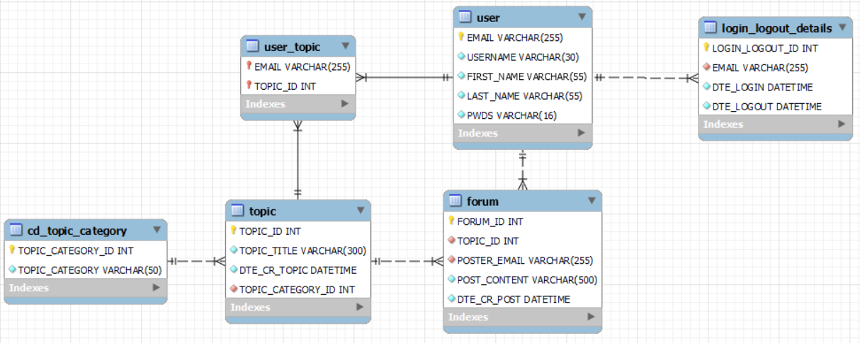

## Create Table

Below are the SQL scripts for table creation.

### SFVI.FORUM

CREATE TABLE SFVI.FORUM (

FORUM_ID INT AUTO_INCREMENT PRIMARY KEY,

TOPIC_ID INT NOT NULL,

POSTER_EMAIL VARCHAR(255) NOT NULL,

POST_CONTENT VARCHAR(500) NOT NULL,

DTE_CR_POST DATETIME NOT NULL DEFAULT CURRENT_TIMESTAMP,

FOREIGN KEY (TOPIC_ID) REFERENCES SFVI.TOPIC(TOPIC_ID),

FOREIGN KEY (POSTER_EMAIL) REFERENCES SFVI.USER(EMAIL)

);

### SFVI.LOGIN_LOGOUT_DETAILS

CREATE TABLE SFVI.LOGIN_LOGOUT_DETAILS (

LOGIN_LOGOUT_ID INT AUTO_INCREMENT PRIMARY KEY,

EMAIL VARCHAR(255) NOT NULL,

DTE_LOGIN DATETIME NOT NULL DEFAULT CURRENT_TIMESTAMP,

DTE_LOGOUT DATETIME NOT NULL,

FOREIGN KEY (EMAIL) REFERENCES sfvi.USER(EMAIL)

);

## Loading Tables From CSV

SQL scripts to load the data from csv files to tables. Please note that MySQL Workbench 8.0 CE is running with --secure-file-priv option. By executing the command SHOW VARIABLES LIKE "secure_file_priv"; it tells us that we need to put the csv files in C:\ProgramData\MySQL\MySQL Server 8.0\Uploads.



### SFVI.FORUM

LOAD DATA INFILE 'C:/ProgramData/MySQL/MySQL Server 8.0/Uploads/FORUM.csv'

INTO TABLE SFVI.FORUM

FIELDS TERMINATED BY ','

ENCLOSED BY '"'

LINES TERMINATED BY '\n'

IGNORE 1 ROWS

(forum_id, topic_id, poster_email, post_content, @dte_cr_post)

SET dte_cr_post = STR_TO_DATE( @dte_cr_post, '%d/%m/%Y %H:%i:%s');

**Output:**

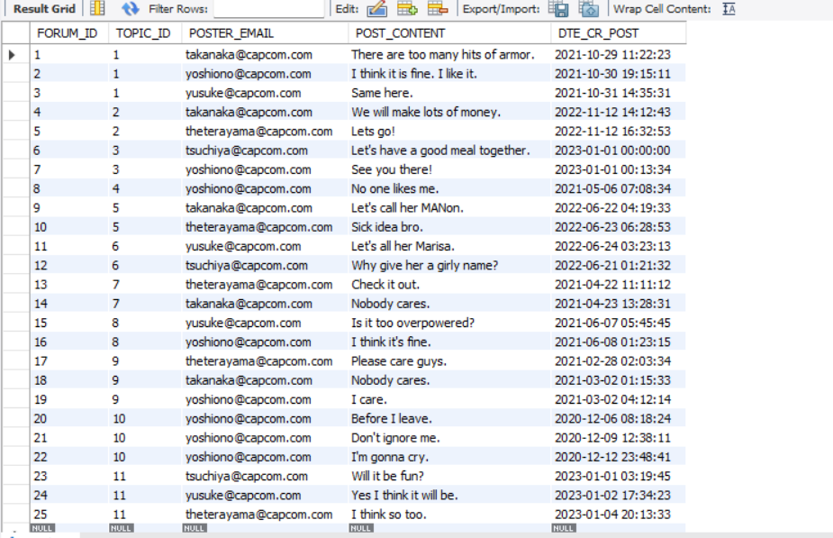

### SFVI.LOGIN_LOGOUT_DETAILS

LOAD DATA INFILE 'C:/ProgramData/MySQL/MySQL Server 8.0/Uploads/LOGIN_LOGOUT_DETAILS.csv'

INTO TABLE SFVI.LOGIN_LOGOUT_DETAILS

FIELDS TERMINATED BY ','

ENCLOSED BY '"'

LINES TERMINATED BY '\n'

IGNORE 1 ROWS

(LOGIN_LOGOUT_ID, EMAIL, @DTE_LOGIN, @DTE_LOGOUT)

SET DTE_LOGIN = STR_TO_DATE( @DTE_LOGIN, '%d/%m/%Y %H:%i:%s'),

DTE_LOGOUT = STR_TO_DATE( @DTE_LOGOUT, '%d/%m/%Y %H:%i:%s');

**Output:**

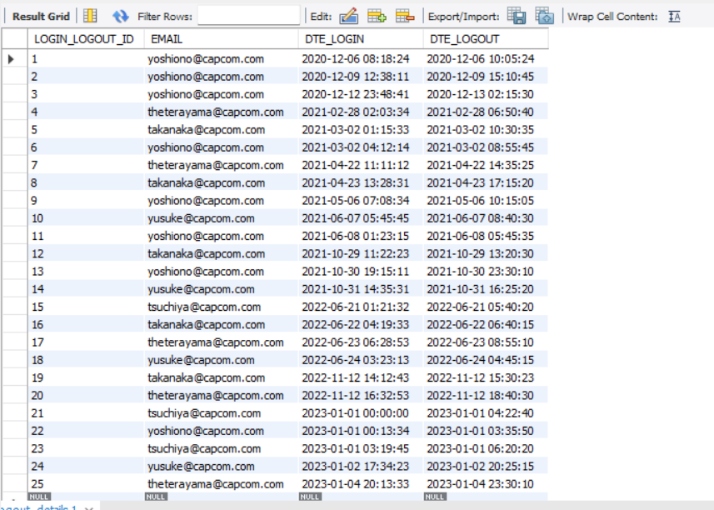

## Load Tables Using Insert Statements

Below are the SQL scripts to load the table using insert statements as an alternative of loading the tables from CSV files.

### SFVI.FORUM

INSERT sfvi.forum (topic_id, poster_email, post_content, dte_cr_post) values (1, 'takanaka@capcom.com', 'There are too many hits of armor.', STR_TO_DATE("29/10/2021 11:22:23", "%d/%m/%Y %H:%i:%s"));

INSERT sfvi.forum (topic_id, poster_email, post_content, dte_cr_post) values (1, 'yoshiono@capcom.com', 'I think it is fine. I like it.', STR_TO_DATE("30/10/2021 19:15:11", "%d/%m/%Y %H:%i:%s"));

INSERT sfvi.forum (topic_id, poster_email, post_content, dte_cr_post) values (1, 'yusuke@capcom.com', 'Same here.', STR_TO_DATE("31/10/2021 14:35:31", "%d/%m/%Y %H:%i:%s"));

INSERT sfvi.forum (topic_id, poster_email, post_content, dte_cr_post) values (2, 'takanaka@capcom.com', 'We will make lots of money.', STR_TO_DATE("12/11/2022 14:12:43", "%d/%m/%Y %H:%i:%s"));

INSERT sfvi.forum (topic_id, poster_email, post_content, dte_cr_post) values (2, 'theterayama@capcom.com', 'Lets go!', STR_TO_DATE("12/11/2022 16:32:53", "%d/%m/%Y %H:%i:%s"));

INSERT sfvi.forum (topic_id, poster_email, post_content, dte_cr_post) values (3, 'tsuchiya@capcom.com', 'Let''s have a good meal together.', STR_TO_DATE("01/01/2023 00:00:00", "%d/%m/%Y %H:%i:%s"));

INSERT sfvi.forum (topic_id, poster_email, post_content, dte_cr_post) values (3, 'yoshiono@capcom.com', 'See you there!', STR_TO_DATE("01/01/2023 00:13:34", "%d/%m/%Y %H:%i:%s"));

INSERT sfvi.forum (topic_id, poster_email, post_content, dte_cr_post) values (4, 'yoshiono@capcom.com', 'No one likes me.', STR_TO_DATE("06/05/2021 07:08:34", "%d/%m/%Y %H:%i:%s"));

INSERT sfvi.forum (topic_id, poster_email, post_content, dte_cr_post) values (5, 'takanaka@capcom.com', 'Let''s call her MANon.', STR_TO_DATE("22/06/2022 04:19:33", "%d/%m/%Y %H:%i:%s"));

INSERT sfvi.forum (topic_id, poster_email, post_content, dte_cr_post) values (5, 'theterayama@capcom.com', 'Sick idea bro.', STR_TO_DATE("23/06/2022 06:28:53", "%d/%m/%Y %H:%i:%s"));

INSERT sfvi.forum (topic_id, poster_email, post_content, dte_cr_post) values (6, 'yusuke@capcom.com', 'Let''s all her Marisa.', STR_TO_DATE("24/06/2022 03:23:13", "%d/%m/%Y %H:%i:%s"));

INSERT sfvi.forum (topic_id, poster_email, post_content, dte_cr_post) values (6, 'tsuchiya@capcom.com', 'Why give her a girly name?', STR_TO_DATE("21/06/2022 01:21:32", "%d/%m/%Y %H:%i:%s"));

INSERT sfvi.forum (topic_id, poster_email, post_content, dte_cr_post) values (7, 'theterayama@capcom.com', 'Check it out.', STR_TO_DATE("22/04/2021 11:11:12", "%d/%m/%Y %H:%i:%s"));

INSERT sfvi.forum (topic_id, poster_email, post_content, dte_cr_post) values (7, 'takanaka@capcom.com', 'Nobody cares.', STR_TO_DATE("23/04/2021 13:28:31", "%d/%m/%Y %H:%i:%s"));

INSERT sfvi.forum (topic_id, poster_email, post_content, dte_cr_post) values (8, 'yusuke@capcom.com', 'Is it too overpowered?', STR_TO_DATE("07/06/2021 05:45:45", "%d/%m/%Y %H:%i:%s"));

INSERT sfvi.forum (topic_id, poster_email, post_content, dte_cr_post) values (8, 'yoshiono@capcom.com', 'I think it''s fine.', STR_TO_DATE("08/06/2021 01:23:15", "%d/%m/%Y %H:%i:%s"));

INSERT sfvi.forum (topic_id, poster_email, post_content, dte_cr_post) values (9, 'theterayama@capcom.com', 'Please care guys.', STR_TO_DATE("28/02/2021 02:03:34", "%d/%m/%Y %H:%i:%s"));

INSERT sfvi.forum (topic_id, poster_email, post_content, dte_cr_post) values (9, 'takanaka@capcom.com', 'Nobody cares.', STR_TO_DATE("02/03/2021 01:15:33", "%d/%m/%Y %H:%i:%s"));

INSERT sfvi.forum (topic_id, poster_email, post_content, dte_cr_post) values (9, 'yoshiono@capcom.com', 'I care.', STR_TO_DATE("02/03/2021 04:12:14", "%d/%m/%Y %H:%i:%s"));

INSERT sfvi.forum (topic_id, poster_email, post_content, dte_cr_post) values (10, 'yoshiono@capcom.com', 'Before I leave.', STR_TO_DATE("06/12/2020 08:18:24", "%d/%m/%Y %H:%i:%s"));

INSERT sfvi.forum (topic_id, poster_email, post_content, dte_cr_post) values (10, 'yoshiono@capcom.com', 'Don''t ignore me.', STR_TO_DATE("09/12/2020 12:38:11", "%d/%m/%Y %H:%i:%s"));

INSERT sfvi.forum (topic_id, poster_email, post_content, dte_cr_post) values (10, 'yoshiono@capcom.com', 'I''m gonna cry.', STR_TO_DATE("12/12/2020 23:48:41", "%d/%m/%Y %H:%i:%s"));

INSERT sfvi.forum (topic_id, poster_email, post_content, dte_cr_post) values (11, 'tsuchiya@capcom.com', 'Will it be fun?', STR_TO_DATE("01/01/2023 03:19:45", "%d/%m/%Y %H:%i:%s"));

INSERT sfvi.forum (topic_id, poster_email, post_content, dte_cr_post) values (11, 'yusuke@capcom.com', 'Yes I think it will be.', STR_TO_DATE("02/01/2023 17:34:23", "%d/%m/%Y %H:%i:%s"));

INSERT sfvi.forum (topic_id, poster_email, post_content, dte_cr_post) values (11, 'theterayama@capcom.com', 'I think so too.', STR_TO_DATE("04/01/2023 20:13:33", "%d/%m/%Y %H:%i:%s"));

### SFVI.LOGIN_LOGOUT_DETAILS

INSERT INTO SFVI.LOGIN_LOGOUT_DETAILS (LOGIN_LOGOUT_ID,EMAIL,DTE_LOGIN,DTE_LOGOUT) VALUES (1,'yoshiono@capcom.com',STR_TO_DATE("06/12/2020 08:18:24", "%d/%m/%Y %H:%i:%s"), STR_TO_DATE("06/12/2020 10:05:24", "%d/%m/%Y %H:%i:%s"));

INSERT INTO SFVI.LOGIN_LOGOUT_DETAILS (LOGIN_LOGOUT_ID,EMAIL,DTE_LOGIN,DTE_LOGOUT) VALUES (2,'yoshiono@capcom.com',STR_TO_DATE("09/12/2020 12:38:11", "%d/%m/%Y %H:%i:%s"), STR_TO_DATE("09/12/2020 15:10:45", "%d/%m/%Y %H:%i:%s"));

INSERT INTO SFVI.LOGIN_LOGOUT_DETAILS (LOGIN_LOGOUT_ID,EMAIL,DTE_LOGIN,DTE_LOGOUT) VALUES (3,'yoshiono@capcom.com',STR_TO_DATE("12/12/2020 23:48:41", "%d/%m/%Y %H:%i:%s"), STR_TO_DATE("13/12/2020 02:15:30", "%d/%m/%Y %H:%i:%s"));

INSERT INTO SFVI.LOGIN_LOGOUT_DETAILS (LOGIN_LOGOUT_ID,EMAIL,DTE_LOGIN,DTE_LOGOUT) VALUES (4,'theterayama@capcom.com',STR_TO_DATE("28/02/2021 02:03:34", "%d/%m/%Y %H:%i:%s"), STR_TO_DATE("28/02/2021 06:50:40", "%d/%m/%Y %H:%i:%s"));

INSERT INTO SFVI.LOGIN_LOGOUT_DETAILS (LOGIN_LOGOUT_ID,EMAIL,DTE_LOGIN,DTE_LOGOUT) VALUES (5,'takanaka@capcom.com',STR_TO_DATE("02/03/2021 01:15:33", "%d/%m/%Y %H:%i:%s"), STR_TO_DATE("02/03/2021 10:30:35", "%d/%m/%Y %H:%i:%s"));

INSERT INTO SFVI.LOGIN_LOGOUT_DETAILS (LOGIN_LOGOUT_ID,EMAIL,DTE_LOGIN,DTE_LOGOUT) VALUES (6,'yoshiono@capcom.com',STR_TO_DATE("02/03/2021 04:12:14", "%d/%m/%Y %H:%i:%s"), STR_TO_DATE("02/03/2021 08:55:45", "%d/%m/%Y %H:%i:%s"));

INSERT INTO SFVI.LOGIN_LOGOUT_DETAILS (LOGIN_LOGOUT_ID,EMAIL,DTE_LOGIN,DTE_LOGOUT) VALUES (7,'theterayama@capcom.com',STR_TO_DATE("22/04/2021 11:11:12", "%d/%m/%Y %H:%i:%s"), STR_TO_DATE("22/04/2021 14:35:25", "%d/%m/%Y %H:%i:%s"));

INSERT INTO SFVI.LOGIN_LOGOUT_DETAILS (LOGIN_LOGOUT_ID,EMAIL,DTE_LOGIN,DTE_LOGOUT) VALUES (8,'takanaka@capcom.com',STR_TO_DATE("23/04/2021 13:28:31", "%d/%m/%Y %H:%i:%s"), STR_TO_DATE("23/04/2021 17:15:20", "%d/%m/%Y %H:%i:%s"));

INSERT INTO SFVI.LOGIN_LOGOUT_DETAILS (LOGIN_LOGOUT_ID,EMAIL,DTE_LOGIN,DTE_LOGOUT) VALUES (9,'yoshiono@capcom.com',STR_TO_DATE("06/05/2021 07:08:34", "%d/%m/%Y %H:%i:%s"), STR_TO_DATE("06/05/2021 10:15:05", "%d/%m/%Y %H:%i:%s"));

INSERT INTO SFVI.LOGIN_LOGOUT_DETAILS (LOGIN_LOGOUT_ID,EMAIL,DTE_LOGIN,DTE_LOGOUT) VALUES (10,'yusuke@capcom.com',STR_TO_DATE("07/06/2021 05:45:45", "%d/%m/%Y %H:%i:%s"), STR_TO_DATE("07/06/2021 08:40:30", "%d/%m/%Y %H:%i:%s"));

INSERT INTO SFVI.LOGIN_LOGOUT_DETAILS (LOGIN_LOGOUT_ID,EMAIL,DTE_LOGIN,DTE_LOGOUT) VALUES (11,'yoshiono@capcom.com',STR_TO_DATE("08/06/2021 01:23:15", "%d/%m/%Y %H:%i:%s"), STR_TO_DATE("08/06/2021 05:45:35", "%d/%m/%Y %H:%i:%s"));

INSERT INTO SFVI.LOGIN_LOGOUT_DETAILS (LOGIN_LOGOUT_ID,EMAIL,DTE_LOGIN,DTE_LOGOUT) VALUES (12,'takanaka@capcom.com',STR_TO_DATE("29/10/2021 11:22:23", "%d/%m/%Y %H:%i:%s"), STR_TO_DATE("29/10/2021 13:20:30", "%d/%m/%Y %H:%i:%s"));

INSERT INTO SFVI.LOGIN_LOGOUT_DETAILS (LOGIN_LOGOUT_ID,EMAIL,DTE_LOGIN,DTE_LOGOUT) VALUES (13,'yoshiono@capcom.com',STR_TO_DATE("30/10/2021 19:15:11", "%d/%m/%Y %H:%i:%s"), STR_TO_DATE("30/10/2021 23:30:10", "%d/%m/%Y %H:%i:%s"));

INSERT INTO SFVI.LOGIN_LOGOUT_DETAILS (LOGIN_LOGOUT_ID,EMAIL,DTE_LOGIN,DTE_LOGOUT) VALUES (14,'yusuke@capcom.com',STR_TO_DATE("31/10/2021 14:35:31", "%d/%m/%Y %H:%i:%s"), STR_TO_DATE("31/10/2021 16:25:20", "%d/%m/%Y %H:%i:%s"));

INSERT INTO SFVI.LOGIN_LOGOUT_DETAILS (LOGIN_LOGOUT_ID,EMAIL,DTE_LOGIN,DTE_LOGOUT) VALUES (15,'tsuchiya@capcom.com',STR_TO_DATE("21/06/2022 01:21:32", "%d/%m/%Y %H:%i:%s"), STR_TO_DATE("21/06/2022 05:40:20", "%d/%m/%Y %H:%i:%s"));

INSERT INTO SFVI.LOGIN_LOGOUT_DETAILS (LOGIN_LOGOUT_ID,EMAIL,DTE_LOGIN,DTE_LOGOUT) VALUES (16,'takanaka@capcom.com',STR_TO_DATE("22/06/2022 04:19:33", "%d/%m/%Y %H:%i:%s"), STR_TO_DATE("22/06/2022 06:40:15", "%d/%m/%Y %H:%i:%s"));

INSERT INTO SFVI.LOGIN_LOGOUT_DETAILS (LOGIN_LOGOUT_ID,EMAIL,DTE_LOGIN,DTE_LOGOUT) VALUES (17,'theterayama@capcom.com',STR_TO_DATE("23/06/2022 06:28:53", "%d/%m/%Y %H:%i:%s"), STR_TO_DATE("23/06/2022 08:55:10", "%d/%m/%Y %H:%i:%s"));

INSERT INTO SFVI.LOGIN_LOGOUT_DETAILS (LOGIN_LOGOUT_ID,EMAIL,DTE_LOGIN,DTE_LOGOUT) VALUES (18,'yusuke@capcom.com',STR_TO_DATE("24/06/2022 03:23:13", "%d/%m/%Y %H:%i:%s"), STR_TO_DATE("24/06/2022 04:45:15", "%d/%m/%Y %H:%i:%s"));

INSERT INTO SFVI.LOGIN_LOGOUT_DETAILS (LOGIN_LOGOUT_ID,EMAIL,DTE_LOGIN,DTE_LOGOUT) VALUES (19,'takanaka@capcom.com',STR_TO_DATE("12/11/2022 14:12:43", "%d/%m/%Y %H:%i:%s"), STR_TO_DATE("12/11/2022 15:30:23", "%d/%m/%Y %H:%i:%s"));

INSERT INTO SFVI.LOGIN_LOGOUT_DETAILS (LOGIN_LOGOUT_ID,EMAIL,DTE_LOGIN,DTE_LOGOUT) VALUES (20,'theterayama@capcom.com',STR_TO_DATE("12/11/2022 16:32:53", "%d/%m/%Y %H:%i:%s"), STR_TO_DATE("12/11/2022 18:40:30", "%d/%m/%Y %H:%i:%s"));

INSERT INTO SFVI.LOGIN_LOGOUT_DETAILS (LOGIN_LOGOUT_ID,EMAIL,DTE_LOGIN,DTE_LOGOUT) VALUES (21,'tsuchiya@capcom.com',STR_TO_DATE("01/01/2023 00:00:00", "%d/%m/%Y %H:%i:%s"), STR_TO_DATE("01/01/2023 04:22:40", "%d/%m/%Y %H:%i:%s"));

INSERT INTO SFVI.LOGIN_LOGOUT_DETAILS (LOGIN_LOGOUT_ID,EMAIL,DTE_LOGIN,DTE_LOGOUT) VALUES (22,'yoshiono@capcom.com',STR_TO_DATE("01/01/2023 00:13:34", "%d/%m/%Y %H:%i:%s"), STR_TO_DATE("01/01/2023 03:35:50", "%d/%m/%Y %H:%i:%s"));

INSERT INTO SFVI.LOGIN_LOGOUT_DETAILS (LOGIN_LOGOUT_ID,EMAIL,DTE_LOGIN,DTE_LOGOUT) VALUES (23,'tsuchiya@capcom.com',STR_TO_DATE("01/01/2023 03:19:45", "%d/%m/%Y %H:%i:%s"), STR_TO_DATE("01/01/2023 06:20:20", "%d/%m/%Y %H:%i:%s"));

INSERT INTO SFVI.LOGIN_LOGOUT_DETAILS (LOGIN_LOGOUT_ID,EMAIL,DTE_LOGIN,DTE_LOGOUT) VALUES (24,'yusuke@capcom.com',STR_TO_DATE("02/01/2023 17:34:23", "%d/%m/%Y %H:%i:%s"), STR_TO_DATE("02/01/2023 20:25:15", "%d/%m/%Y %H:%i:%s"));

INSERT INTO SFVI.LOGIN_LOGOUT_DETAILS (LOGIN_LOGOUT_ID,EMAIL,DTE_LOGIN,DTE_LOGOUT) VALUES (25,'theterayama@capcom.com',STR_TO_DATE("04/01/2023 20:13:33", "%d/%m/%Y %H:%i:%s"), STR_TO_DATE("04/01/2023 23:30:10", "%d/%m/%Y %H:%i:%s"));

## Usage Report

### Number of Topics and Posts

Generate the number of topics each user has created, and the number of posts each user has made.

SELECT

u.email AS user_email,

(SELECT count(topic_id) FROM sfvi.user_topic WHERE email = u.email) AS numbers_of_topics,

(SELECT count(forum_id) FROM sfvi.forum WHERE poster_email = u.email) AS numbers_of_posts

FROM

sfvi.user u

ORDER BY

email;

**Output:**

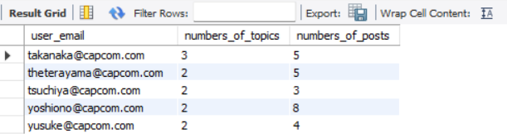

### Time Spent On The Game

Generate the total amount of time each user spent on the game by using an additional table ‘SFVI.LOGIN_LOGOUT_DETAILS’.

SELECT email, sum(hours) total_hours FROM

(

SELECT

email, TIMESTAMPDIFF(hour, dte_login, dte_logout)Hours

FROM

SFVI.LOGIN_LOGOUT_DETAILS

) a

GROUP BY

email;

Output:

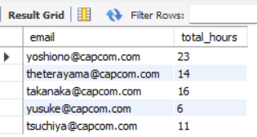

# Part 3: New Features

## ER Diagram

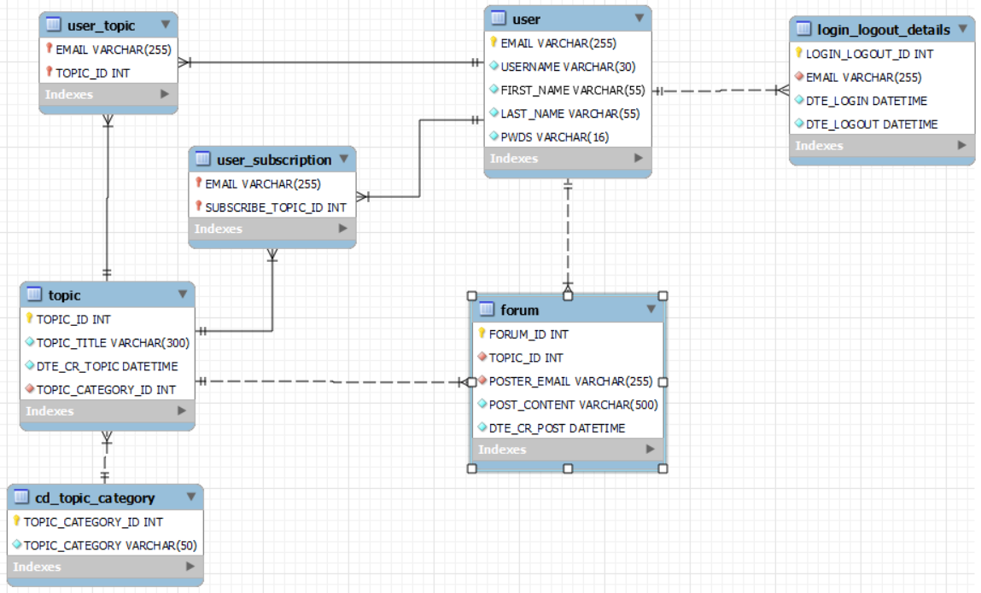

## Create Table

Below are the SQL scripts for table creation.

### SFVI.USER_SUBSCRIPTION

CREATE TABLE SFVI.USER_SUBSCRIPTION (

EMAIL VARCHAR(255),

SUBSCRIBE_TOPIC_ID INT,

PRIMARY KEY (EMAIL, SUBSCRIBE_TOPIC_ID),

FOREIGN KEY (EMAIL) REFERENCES SFVI.USER(EMAIL),

FOREIGN KEY (SUBSCRIBE_TOPIC_ID) REFERENCES SFVI.TOPIC(TOPIC_ID)

);

## Loading Tables From CSV

SQL scripts to load the data from csv files to tables. Please note that MySQL Workbench 8.0 CE is running with --secure-file-priv option. By executing the command SHOW VARIABLES LIKE "secure_file_priv"; it tells us that we need to put the csv files in C:\ProgramData\MySQL\MySQL Server 8.0\Uploads.



### SFVI.USER_SUBSCRIPTION

LOAD DATA INFILE 'C:/ProgramData/MySQL/MySQL Server 8.0/Uploads/USER_SUBSCRIPTION.csv'

INTO TABLE SFVI.USER_SUBSCRIPTION

FIELDS TERMINATED BY ','

ENCLOSED BY '"'

LINES TERMINATED BY '\n'

IGNORE 1 ROWS

(EMAIL, SUBSCRIBE_TOPIC_ID);

**Output:**

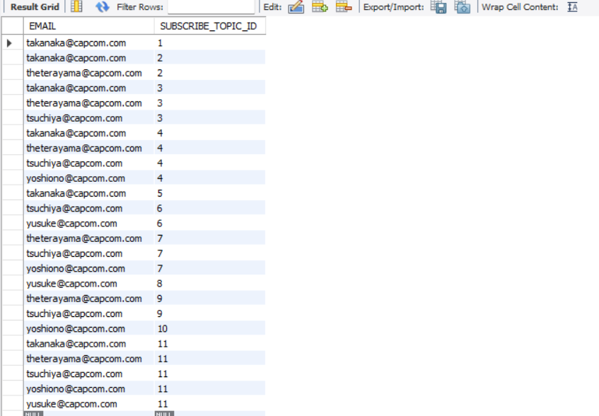

## Load Tables Using Insert Statements

Below are the SQL scripts to load the table using insert statements as an alternative of loading the tables from CSV files.

### SFVI.USER_SUBSCRIPTION

INSERT INTO sfvi.user_subscription (EMAIL, SUBSCRIBE_TOPIC_ID) VALUES ('takanaka@capcom.com',1);

INSERT INTO sfvi.user_subscription (EMAIL, SUBSCRIBE_TOPIC_ID) VALUES ('takanaka@capcom.com',2);

INSERT INTO sfvi.user_subscription (EMAIL, SUBSCRIBE_TOPIC_ID) VALUES ('theterayama@capcom.com',2);

INSERT INTO sfvi.user_subscription (EMAIL, SUBSCRIBE_TOPIC_ID) VALUES ('takanaka@capcom.com',3);

INSERT INTO sfvi.user_subscription (EMAIL, SUBSCRIBE_TOPIC_ID) VALUES ('theterayama@capcom.com',3);

INSERT INTO sfvi.user_subscription (EMAIL, SUBSCRIBE_TOPIC_ID) VALUES ('tsuchiya@capcom.com',3);

INSERT INTO sfvi.user_subscription (EMAIL, SUBSCRIBE_TOPIC_ID) VALUES ('takanaka@capcom.com',4);

INSERT INTO sfvi.user_subscription (EMAIL, SUBSCRIBE_TOPIC_ID) VALUES ('theterayama@capcom.com',4);

INSERT INTO sfvi.user_subscription (EMAIL, SUBSCRIBE_TOPIC_ID) VALUES ('tsuchiya@capcom.com',4);

INSERT INTO sfvi.user_subscription (EMAIL, SUBSCRIBE_TOPIC_ID) VALUES ('yoshiono@capcom.com',4);

INSERT INTO sfvi.user_subscription (EMAIL, SUBSCRIBE_TOPIC_ID) VALUES ('takanaka@capcom.com',5);

INSERT INTO sfvi.user_subscription (EMAIL, SUBSCRIBE_TOPIC_ID) VALUES ('tsuchiya@capcom.com',6);

INSERT INTO sfvi.user_subscription (EMAIL, SUBSCRIBE_TOPIC_ID) VALUES ('yusuke@capcom.com',6);

INSERT INTO sfvi.user_subscription (EMAIL, SUBSCRIBE_TOPIC_ID) VALUES ('theterayama@capcom.com',7);

INSERT INTO sfvi.user_subscription (EMAIL, SUBSCRIBE_TOPIC_ID) VALUES ('tsuchiya@capcom.com',7);

INSERT INTO sfvi.user_subscription (EMAIL, SUBSCRIBE_TOPIC_ID) VALUES ('yoshiono@capcom.com',7);

INSERT INTO sfvi.user_subscription (EMAIL, SUBSCRIBE_TOPIC_ID) VALUES ('yusuke@capcom.com',8);

INSERT INTO sfvi.user_subscription (EMAIL, SUBSCRIBE_TOPIC_ID) VALUES ('theterayama@capcom.com',9);

INSERT INTO sfvi.user_subscription (EMAIL, SUBSCRIBE_TOPIC_ID) VALUES ('tsuchiya@capcom.com',9);

INSERT INTO sfvi.user_subscription (EMAIL, SUBSCRIBE_TOPIC_ID) VALUES ('yoshiono@capcom.com',10);

INSERT INTO sfvi.user_subscription (EMAIL, SUBSCRIBE_TOPIC_ID) VALUES ('takanaka@capcom.com',11);

INSERT INTO sfvi.user_subscription (EMAIL, SUBSCRIBE_TOPIC_ID) VALUES ('theterayama@capcom.com',11);

INSERT INTO sfvi.user_subscription (EMAIL, SUBSCRIBE_TOPIC_ID) VALUES ('tsuchiya@capcom.com',11);

INSERT INTO sfvi.user_subscription (EMAIL, SUBSCRIBE_TOPIC_ID) VALUES ('yoshiono@capcom.com',11);

INSERT INTO sfvi.user_subscription (EMAIL, SUBSCRIBE_TOPIC_ID) VALUES ('yusuke@capcom.com',11);

## SQL Query

### Number of Posts Between October 2022 to December 2022

Below is the SQL query showing the number of posts a user has made between October 2022 to December 2022

SELECT

poster_email, count(*) AS number_of_posts

FROM

sfvi.forum

WHERE

dte_cr_post BETWEEN '2022-10-01' AND '2022-12-31'

GROUP BY

poster_email;

**Output:**

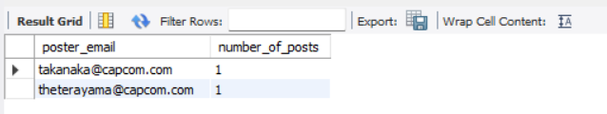

### Number of Post by Quarter

Below is the SQL query showing the number of posts all users has posted in the different quarters.

SELECT

poster_email, concat(YEAR(dte_cr_post) ,'-Q', QUARTER(dte_cr_post)) AS quarter_year, count(*) AS no_of_posts

FROM

sfvi.forum

GROUP BY

poster_email, quarter_year

ORDER BY

quarter_year, poster_email;

**Output:**

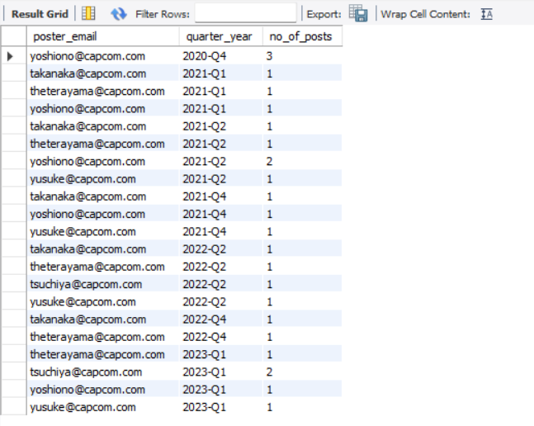

# Summary

Below records some of our learning points and challenges encountered in the project.

**Database schema design**

It is important to apply 3NF in database schema design to reduce redundancy. In our project, we have denormalized the structure in SFVI Forum Users.csv and SFVI Forum Message Data.csv into the following tables:

|  |  |
| --- | --- |
| **Table** | **Description/ Our considerations** |
| **USER** | To store the detail related to users. We use EMAIL as the primary key. |
| **CD_TOPIC_CATEGORY** | To store the detail related to the category of the topics so that the category description does not need to be replicated throughout the TOPIC table. The primary key of this table is the TOPIC_CATEGORY_ID. We use this TOPIC_CATEGORY_ID to join with other tables. |
| **TOPIC** | To store the detail and title related to the topics. We created a unique primary key called TOPIC_ID for each topic so that the topic title would not be replicated in the forum table. |
| **USER_TOPIC** | We decouple the user details from the topics content and only keep the bare minimum user information (i.e. EMAIL) and TOPIC_ID. This helps to maintain the relationship between the users and topics. If we want to know the detail of the user or the detail of the topic content, we can perform a join using EMAIL or TOPIC_ID to the USER table or the TOPIC table respectively. |
| **LOGIN_LOGOUT_DETAILS** | This table keeps track of the login and logout timestamp of the user so that we can use this to compute the time each user spends on the game.  Initially, we wanted to include an additional field in the FORUM table to keep track of the user logout time together with the user posting time. However, the duration between the posting time and logout time will overlap if there is multiple posting records inserted. This will make the computation of duration spent difficult. Hence, we decided to use a separate table to solely keep track of the login and logout activities. |
| **FORUM** | This table keeps the content of the posts posted by the users.  It maintains a relationship between the EMAIL, the TOPIC_ID and the POST_CONTENT.  We do not replicate the topic title in this table. Instead, we just the TOPIC_ID as the foreign key. If we want to know the topic detail such as the title, we can do a join to the TOPIC table |
| **USER_SUBSCRIPTION** | To keep the relationship between SUBSCRIBE_TOPIC_ID and the EMAIL. This design allows users to subscribe to multiple topics.   * To get the user detail, the query can perform a join to the USER table using EMAIL. * To get the topic title, the query can perform a join to the TOPIC table using the SUBSCRIBE_TOPIC_ID. * To get the forum post content of the selected topic, the query can performa a join to the FORUM table using the SUBSCRIBE_TOPIC_ID |
|  |  |
|  |  |
|  |  |
|  |  |

**Sequence of table creation**

After we have designed the database schema, each of us split the work to come out with the CREATE table statements. We have learnt that we must run the scripts in proper sequence. Otherwise, we will hit into error such as Unable to create table due to missing fields referred in the foreign key.

Hence, the rule of thumb is to first create the table with fields that will be referenced as foreign keys in another table, followed by the creation of the foreign keys.

We create our table in this sequence:

1. USER
2. CD_TOPIC_CATEGORY
3. TOPIC
4. FORUM
5. LOGIN_LOGOUT_DETAILS
6. USER_SUBSCRIPTION

**Sequence of data insertion**

Similar to table creation, the sequence to execute the INSERT statements to the various tables is also important. We must make sure that the data being referenced by another table as a foreign key need to be first created in the main table. E.g. We cannot insert a record with a user email “takanaka@capcom.com” into the FORUM table before a record of this email “takanaka@capcom.com” is inserted in the EMAIL field in USER table.

**Insertion of Date format**

The format of date provided in the SFVI Forum Users.csv and SFVI Forum Message Data.csv file is “dd/mm/yyyy hh:mm:ss” (e.g. 29/10/2021 11:22:00)

This is not the standard format of the data time in MySQL. Hence, we are required to convert the data in csv using STR_TO_DATE function e.g. (STR_TO_DATE("12/11/2022 14:12:43", "%d/%m/%Y %H:%i:%s")) to format the data into the system datetime format before insertion.

**Generation of unique TOPIC_ID**

We designed to use a system auto-generated sequence number for the TOPIC_ID. This TOPIC_ID is referred in FORUM table, USER_SUBSCRIPTION table and USER_TOPIC table as a foreign keys. When we are preparing the insert statements for the FORUM table, USER_SUBSCRIPTION table and USER_TOPIC table, we need to make sure that we refer to the correct TOPIC_ID that is auto generated in the TOPIC table. Otherwise, we will hit “TOPIC_ID xxx does not exists” error.

**Computation of posts for a quarter**

Since the post datetime is in “YYYY-MM-DD hh:mm:ss” default format, the counting of the posts using GROUP BY statement is not straightforward. Hence, we need to convert the post datetime into different quarters using the QUARTER function. However, this function only returns the number related to the quarter without the year component. Hence, we also need to get the YEAR from the post datetime. After we have obtained the YEAR and QUARTER, we use CONCAT function to concatenate the year and quarter to form this YYYY-‘Q’Q format (e.g. 2023-Q1) and we doing the GROUP BY using this new field created in the SELECT statement so that we can count by the different quarters.

# Annex A: SFVI Forum Message Data.csv



# Annex B: SFVI Forum Users.csv



# Annex C: CSV Files for Loading













